Multiday UI Adjustment.

A venue that needs multiday rentals should be able to select it from the deep admin menu, much like how VIP can be toggled on and off from the Charge Daddy deep admin menu.
The user experience is the same throughout, a user will select their language option, then select if they want to start a rental or open a locker. Then if they choose to rent a locker they are prompted to choose size and price:
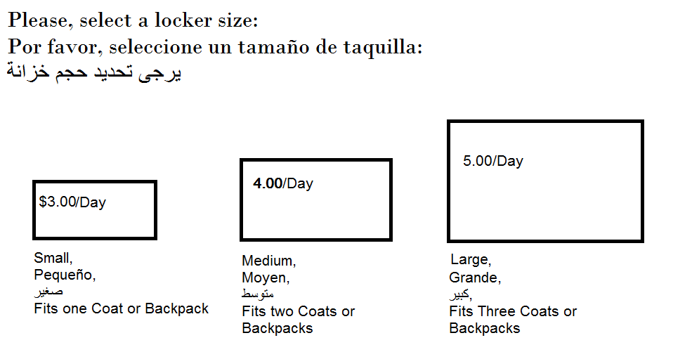
Since we are adjusting the UI, we may want to take the opportunity to improve it with better images, a more intuitive interface and more information to make a better selection. Having objects as a reference point rather than dimensions may be a fit, also if multiple languages fit well on the screen, we can have common regional languages both on the default settings, (IE: Texas parks have Spanish and English on the same screen as a default) , while less common languages can be selected from the main screen.
After selecting a size and price per day for a locker they are prompted with a unique screen if multiday is toggled on:
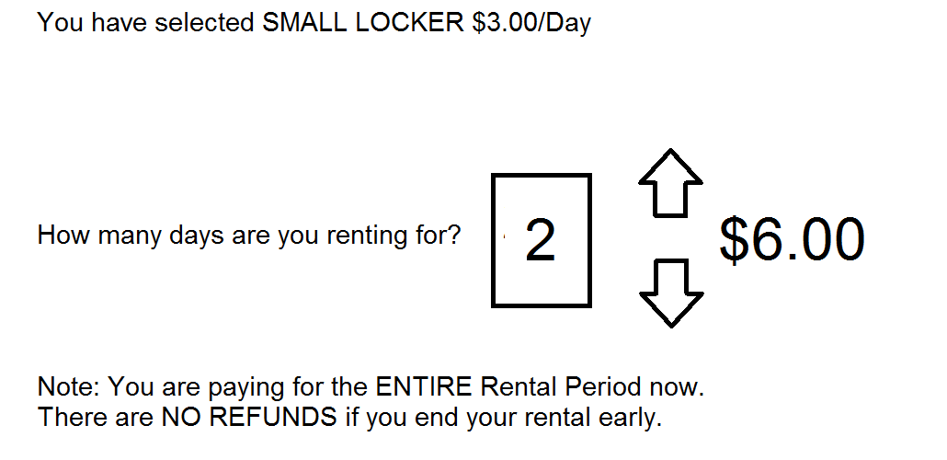
Price is determined by a simple multiplication of price per day and total days rented. The default policy is probably no refunds, but I imagine if someone really argues a high end ski resort would just grant it. I anticipate many people over renting, but few arguing for a small cost refund given the daily cost to be at these resorts.
When this feature combines with a “reservations” feature we will have to carefully program it to ensure that there is no overlap. A business decision will have to be made to which method of renting that we want to support more since the overlap could be messy.

